**Semester End Practical Exam!!**

**Name:** Dhavalkumar Vijaykumar Patel

**Class:** M.Sc. Cyber Security Sem-3

**Enrollment Number:** 032200300002034

**Subject: IoT security and Forensics** (CTMSCS SIII L2)

**Date:** 11 January 2024

**Question 1: Design a system which blinks light at intervals of 2 sec when temperature reaches to 50 degree using Arduino**

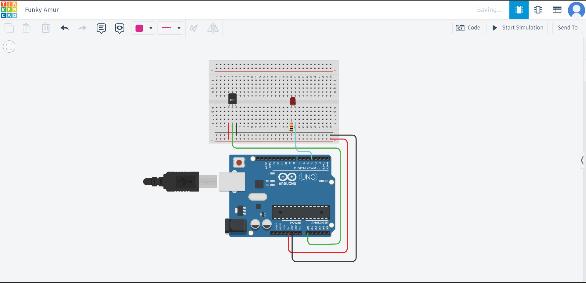

// C++ code

//

int baselineTemp = 0;

int celsius = 0;

void setup()

{

pinMode(A0, INPUT);

Serial.begin(9600);

pinMode(4, OUTPUT);

}

void loop()

{

// set threshold temperature to activate LEDs

baselineTemp = 50;

// measure temperature in Celsius

celsius = map(((analogRead(A0) - 20) * 3.04), 0, 1023, -40, 125);

Serial.print(celsius);

Serial.print(" C, ");

if (celsius >= baselineTemp) {

digitalWrite(4, HIGH);

delay(2000);

digitalWrite(4, LOW);

delay(2000);

}

}

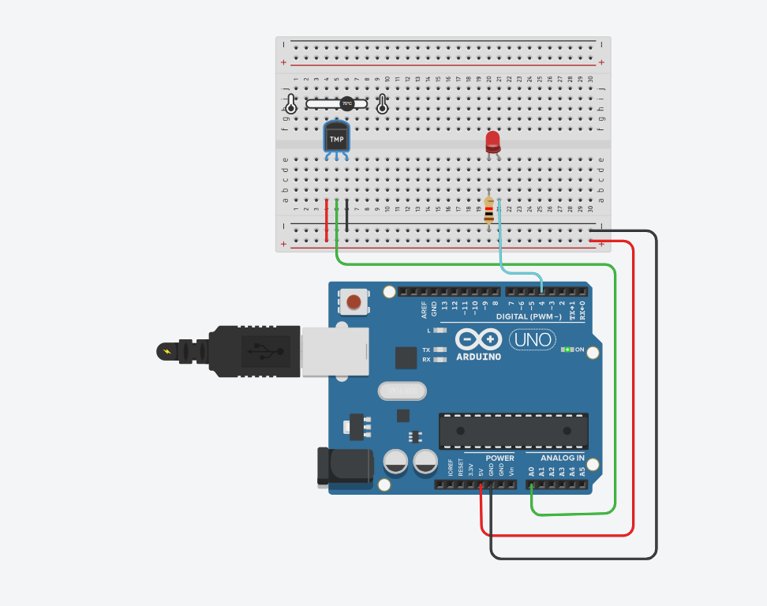

**Question 2: Design a traffic light controller using Arduino**

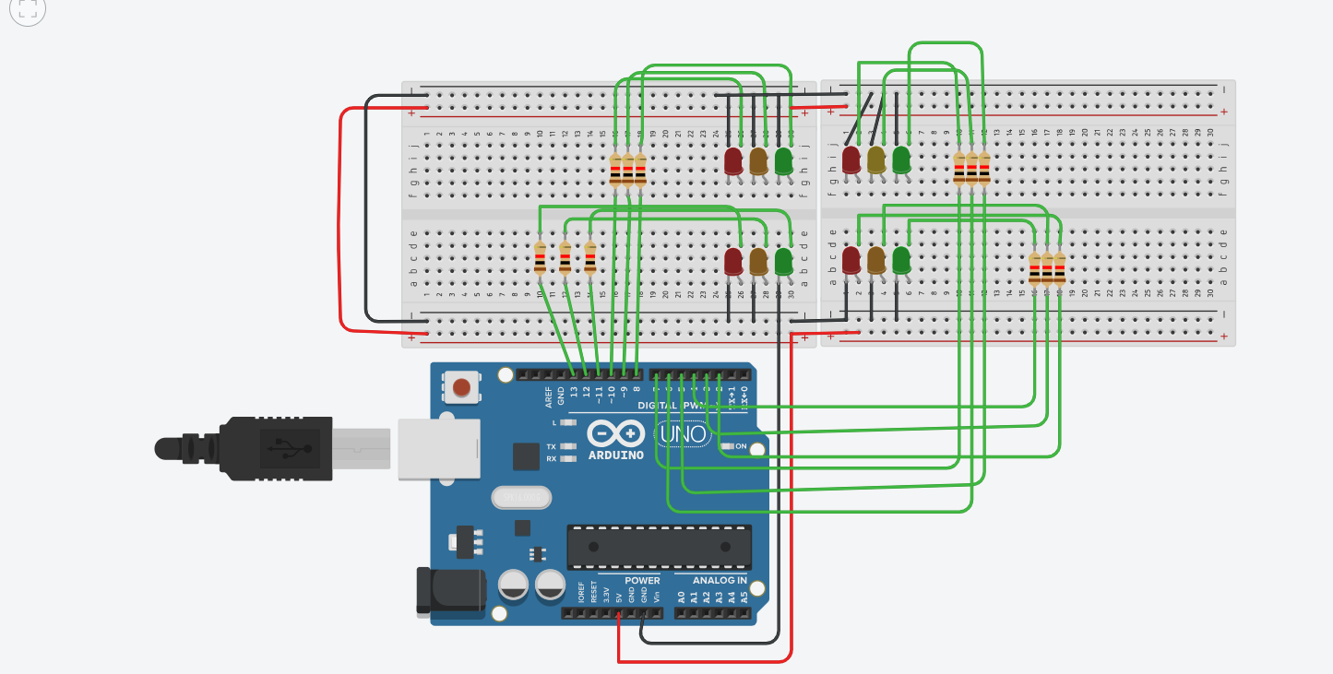

void setup()

{

pinMode(13,OUTPUT);

pinMode(12,OUTPUT);

pinMode(11,OUTPUT);

pinMode(10,OUTPUT);

pinMode(9,OUTPUT);

pinMode(8,OUTPUT);

pinMode(7,OUTPUT);

pinMode(6,OUTPUT);

pinMode(5,OUTPUT);

pinMode(4,OUTPUT);

pinMode(3,OUTPUT);

pinMode(2,OUTPUT);

}

void loop()

{

digitalWrite(13,HIGH);//allow pedistrains

digitalWrite(12,LOW);

digitalWrite(11,LOW);

digitalWrite(10,HIGH);

digitalWrite(9,LOW);

digitalWrite(8,LOW);

digitalWrite(7,HIGH);

digitalWrite(6,LOW);

digitalWrite(5,LOW);

digitalWrite(4,LOW);

digitalWrite(3,LOW);

digitalWrite(2,HIGH);

delay(5000); //wait for 5000 milliseconds(s)

digitalWrite(13,LOW);

digitalWrite(12,HIGH);

delay(3000);//wait for 3000 milliseconds(s)

digitalWrite(12,LOW);

digitalWrite(11,HIGH);

delay(5000);//wait for 10000 milliseconds(s)

digitalWrite(6,LOW);

digitalWrite(5,HIGH);

delay(10000);//wait for 10000 milliseconds(s)

digitalWrite(5,LOW);

digitalWrite(2,LOW);

digitalWrite(3,HIGH);

digitalWrite(7,HIGH);

delay(3000);//wait for 3000 milliseconds(s)

digitalWrite(3,LOW);

digitalWrite(4,HIGH);

delay(10000);//wait for 10000 milliseconds(s)

digitalWrite(4,LOW);

digitalWrite(2,HIGH);

digitalWrite(9,HIGH);

digitalWrite(10,LOW);

delay(3000);//wait for 3000 milliseconds(s)

digitalWrite(9,LOW);

digitalWrite(8,HIGH);

delay(10000); //wait for 10000 milliseconds(s)

}

